

**DIGITALINNOVATORPROGRAMME(DIP)**

**COMPUTER SCIENCE I PSCS2014**

# COMPUTERSCIENCE

**SEMESTER 2 PART 2**

**___________________________________________________________________________________________________________________________________________________________**

**TASK 3 (10% CARRYMARKS)** - **SQL EXERCISE: LIBRARY DATABASE**

**STUDENT NAME:** CHONG LOK PHEN | **CLASS:** 1K6

**INSTRUCTIONS:**

In this individual task, you will develop a basic library database using HeidiSQL and MySQL. The exercise focuses on creating and managing a single table that tracks library books and their borrowing dates.

Key elements to include on your assignment are:

* **Database Structure:** Clear table designs with proper fields and relationships.
* **Data Management**: Sample data entry and manipulation
* **Query Operations:** Various SQL commands to interact with the database
* **Results Documentation:** Screenshots showing successful execution of commands

1. **Setting Up the Environment**

* **Install and Launch Required Software**:

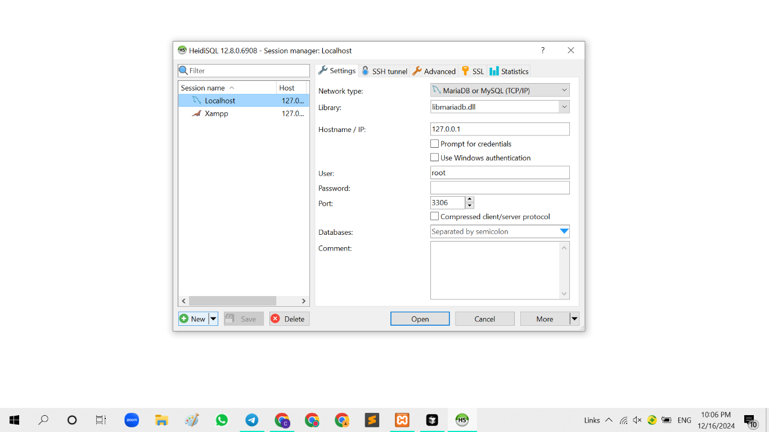 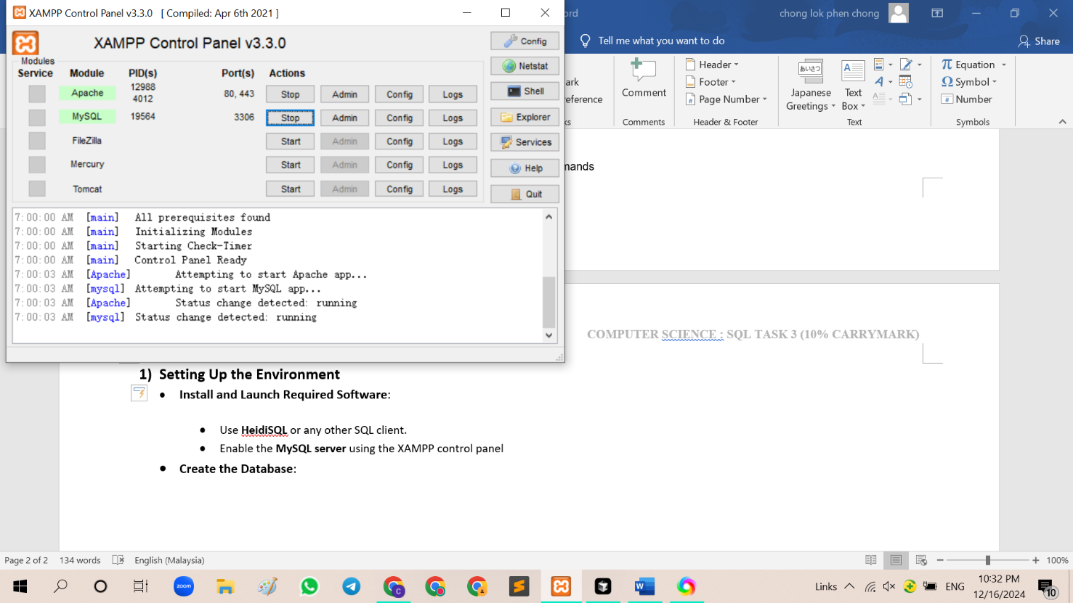

* Use **HeidiSQL** or any other SQL client. - Enable the **MySQL server** using the XAMPP control panel
* **Create the Database**:

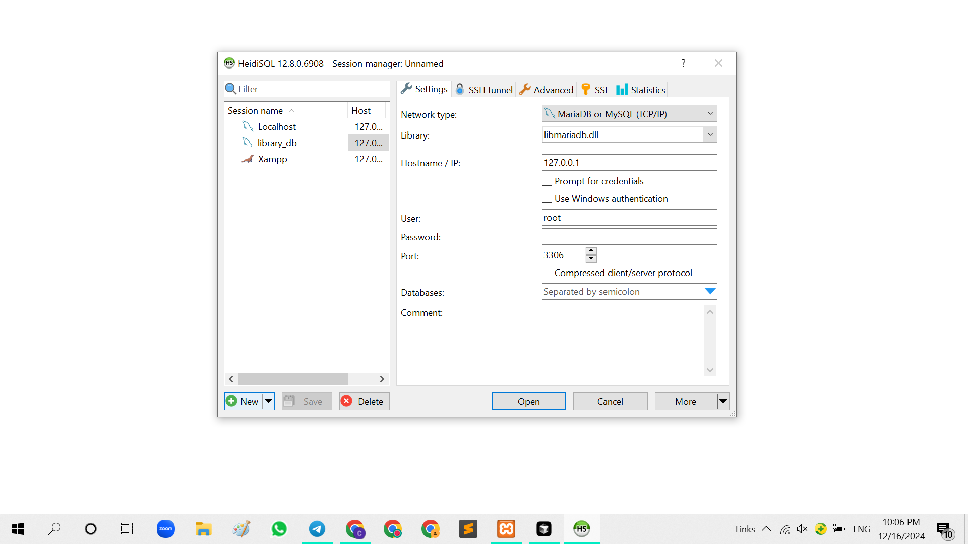

1. **Creating the Table**

* SQL command

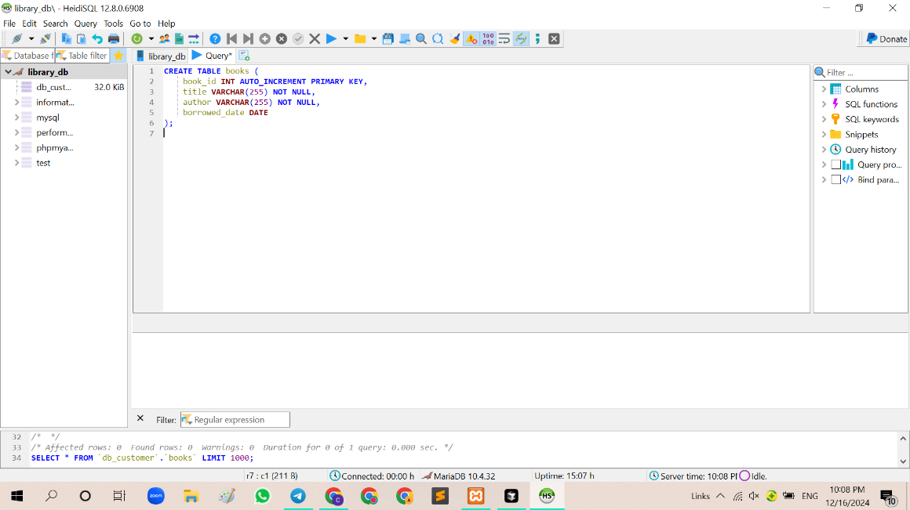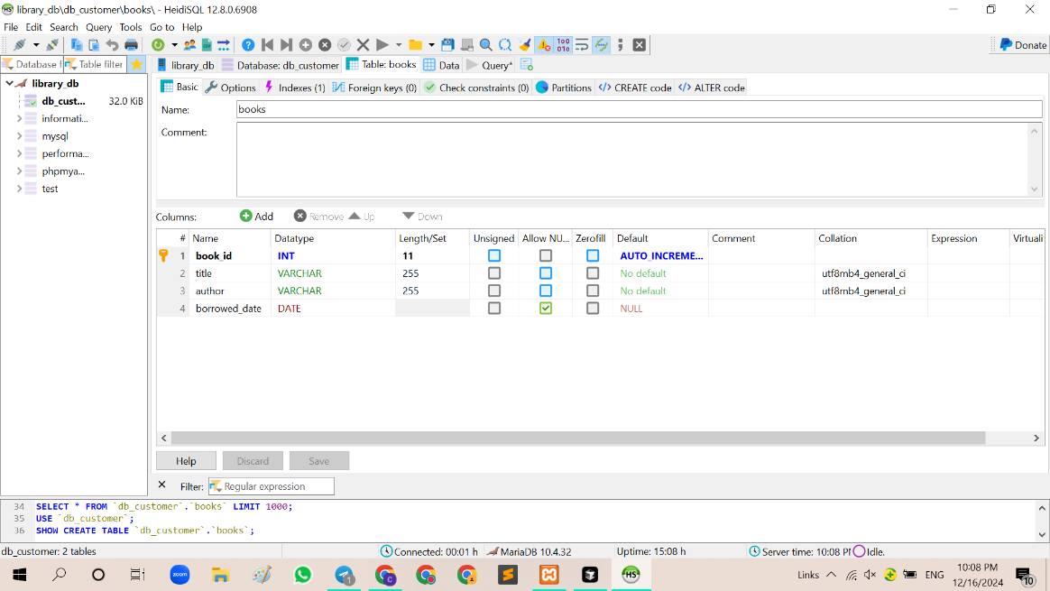

1. **Data Entry**

* SQL command

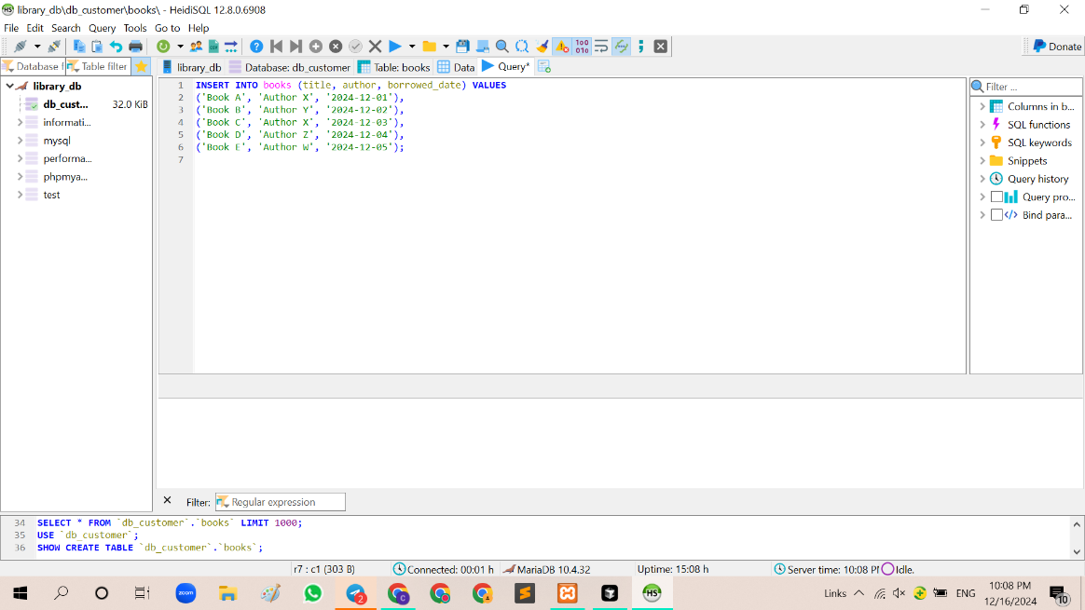

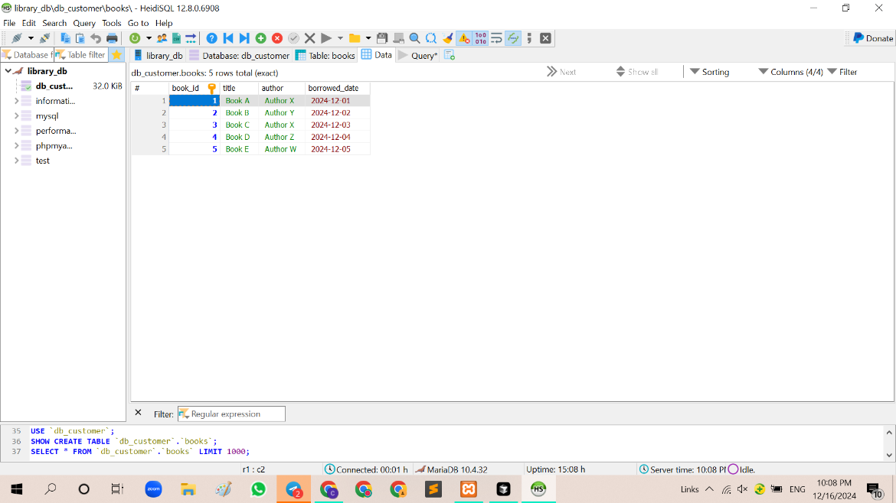

1. **Query Operations**

-List all book titles: **- Find books by author**:

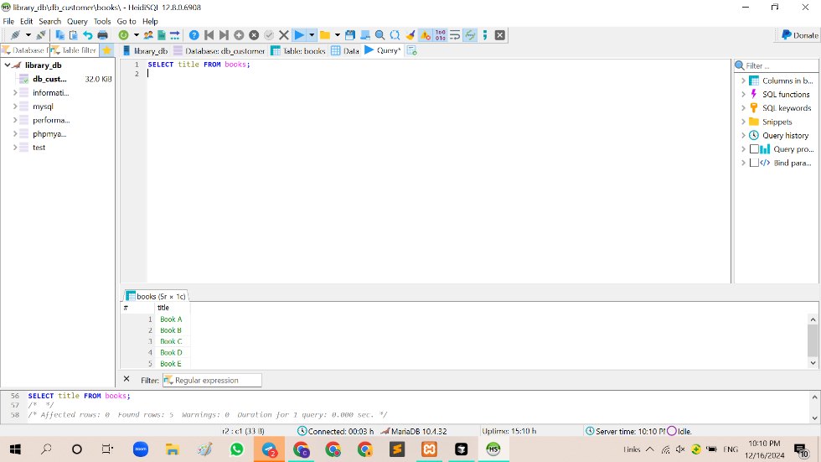 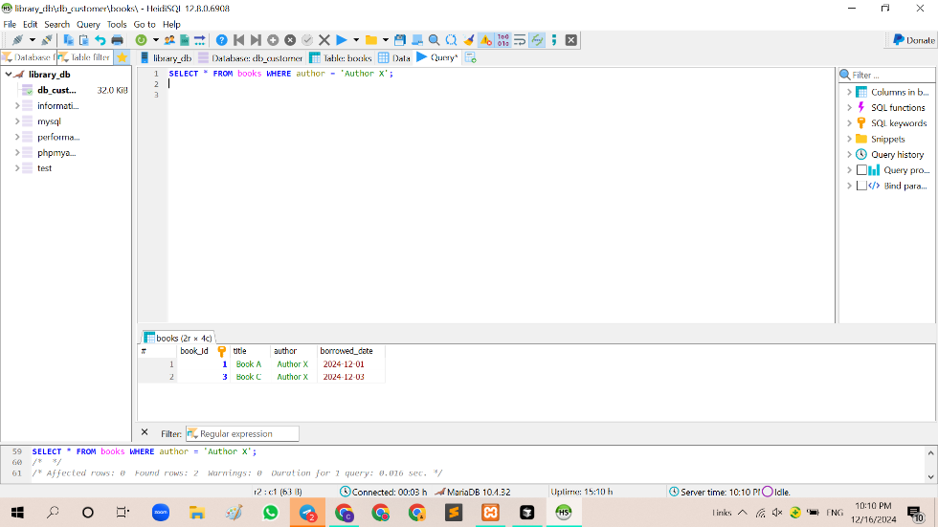

**-Find books borrowed on a specific date: -Find books borrowed after a certain date:**

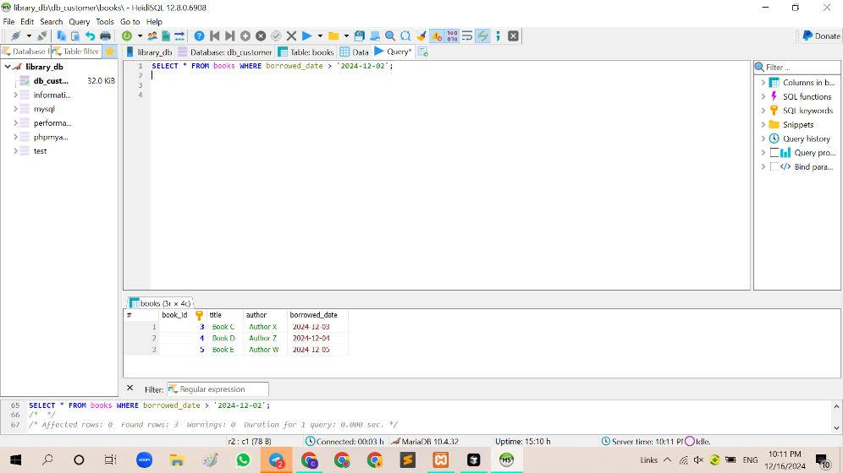 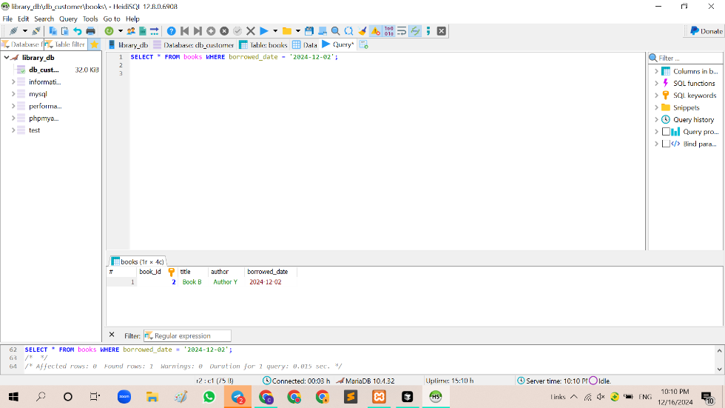

1. **Data Manipulation**

* **Update borrowed_date:**

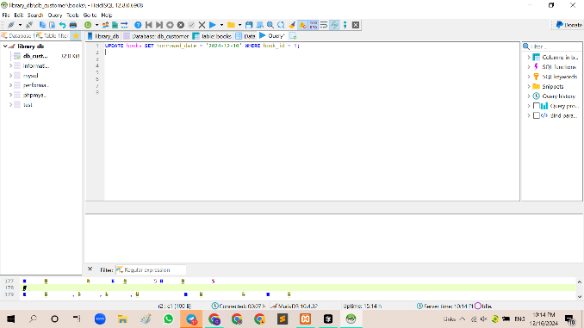 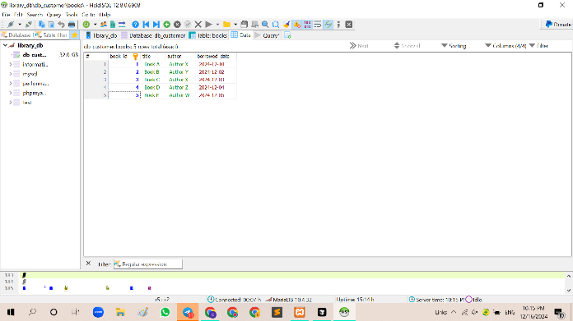

* **Delete a book:**

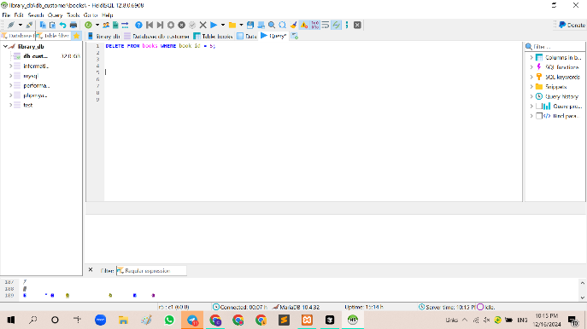 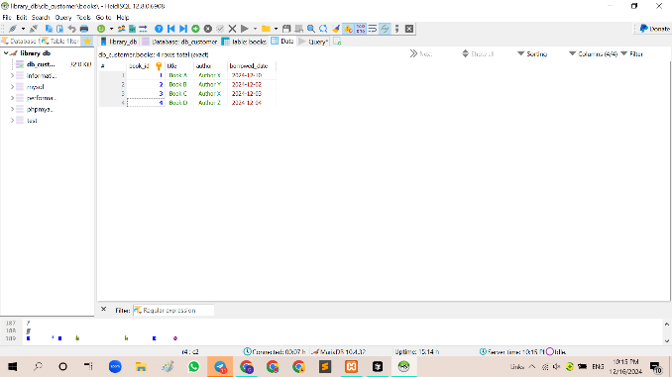

* **Re-add a deleted book:**

